Robotic Hands in MATLAB SynGrasp Toolbox and Experiment at INAIL Budrio Prosthetic centre
Contents
Miscellaneous information 1
Theoretical Background [1], [2] 2
Robotic Grasping Fundamentals 2
SynGrasp Installation [3] [4] 7
First steps in Scripting mode 7
First steps in GUI mode 10
Grasping experiment 11
Fist Closure Animation Exercise 11
Santello Matrix Experiment 13
Fixed bugs in SynGrasp Library 14
Esperimento presso Centro Protesi INAIL di Budrio 15
Il giorno dell’esperimento 16
Riflessioni personali e conclusione 17
References 18

Miscellaneous information
The objective of this internship is to study, design, and simulate control strategies for robotic hands using the MATLAB environment. The project focuses on exploring the capabilities of the SynGrasp toolbox for modelling and simulating robotic hands and specialises on manipulation planning.
The internship will begin with the exploration of the functionalities of the SynGrasp toolbox in MATLAB, learning how to model and simulate robotic hands. Building on this foundation, the work will involve the study of synergy matrices for grasping and interaction tasks, followed by testing the proposed methods in different simulated scenarios. The internship will conclude with an analysis of the results and the preparation of a final technical report to be included in the student’s thesis work.
Additionally, as practical conclusion for the internship, I will take part in an experiment at INAIL Prosthetic Centre in Budrio concerning some grasping tests with Hannes hand prosthesis.
Ἀναξαγόρας μὲν γὰρ διὰ τὰς χεῖρας φησὶν εἶναι φρονιμώτατον τῶν ζῴων τὸν ἄνθρωπον.
~ Ἀριστοτέλης

Theoretical Background [1], [2]
Before starting to analyse the SynGrasp Toolbox for Robot Manipulators, we must first ensure we have a sturdy and reliable theoretical background. Therefore, we will briefly go over the main topics that will aid us later in our work on the MATLAB Toolbox.

Robotic Grasping Fundamentals
1. The Phases of Manipulation: From Reaching to Relocation
Robot manipulation consists of interacting with the environment to change the state of an object and can be decomposed into three phases: reaching, in which the manipulator moves through free space toward the object; establishing contact, where contact dynamics and force control lead to a stable grasp; and object motion, in which the grasped object is transported while maintaining grasp stability under inertial and gravitational effects.
Let’s introduce a few notation details to ensure we can understand the one used in SynGrasp toolbox. We define {N} as the inertial frame for the manipulator, often placed in the palm, and {B} as the reference frame for the object, fixed to it, with its origin expressed in {N}.
2. Power vs. Precision Grasps: The Two Fundamental Approaches
When establishing contact, a robotic hand can employ one of two primary strategies: the power grasp or the precision grasp. The distinction lies in how contact is made and how force is applied.
A power grasp involves using large areas of the fingers and palm to hold the object, effectively grasping it and constraining it from any relative movement with respect to the hand. It is exceptionally stable and allows us to consider hand and object as a single, unique entity, simplifying all kinematic and dynamic considerations. Even though seemingly complex, robotic fingers are usually all composed by 1-DOF rotational joints, which makes control simple, ideal for moving objects around in the workspace.
On the other hand, a precision grasp (or fingertip grasp) involves holding an object using only the tips of the fingers. While less stable and capable of applying smaller forces than a power grasp, it offers significantly greater dexterity and detail. By making contact at discrete points, the manipulator can perform fine, in-hand adjustments to the object's position and orientation. Higher computational complexity is required for this grasp, which has also necessity of knowledge of the object and possible contact models. In this scenario, a manipulation of the object with respect to the palm is possible.
The choice between these grasp types represents a fundamental trade-off between the stability and strength of a power grasp and the dexterity and fine control of a precision grasp.
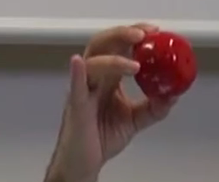
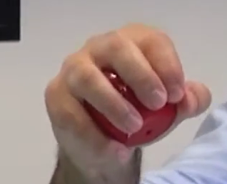
Figure 1: Precision Grasp
Figure 2: Power Grasp
3. The Role of Friction in Maintaining a Stable Grasp
For any non-enveloping grasp, particularly precision grasps, the ability to resist external forces and prevent the object from slipping entirely depends on friction. The interaction at each contact point can be modelled using the concept of the friction cone. This is an imaginary cone whose apex is at the contact point, with its axis aligned with the normal to the object's surface. The angle of the cone is determined by the static coefficient of friction between the fingertip and the object.
To maintain a firm grasp and prevent slippage, the total force vector applied by the fingertip at the contact point must lie within this friction cone. If the force vector moves outside the cone, it means the tangential (frictional) component of the force is insufficient to counteract the applied shear force, and the object will begin to slip. Therefore, a core task in grasp planning is to select contact points and apply forces such that all force vectors remain robustly inside their respective friction cones, even in the presence of external disturbances like gravity or accelerations.
In the event of slipping, the contact points change and the whole model must be recomputed to ensure control, therefore slippage must be avoided.
4. The Grasp Matrix: A Mathematical Model of Grasping Kinematics
To analytically describe the relationship between the forces applied by the fingertips and their effect on the object, we use the Grasp Matrix (G). This matrix provides a linear mapping from the forces and torques applied at the individual contact points to the resultant wrench (net force and torque vector) acting on the object's centre of mass. The relationship is typically expressed as w = G·λ, where w is the 6x1 resultant wrench on the object, λ is a vector stacking all the individual contact forces, and G is the Grasp Matrix.
The structure of the Grasp Matrix is purely geometric. Each column corresponds to a single contact point and describes how a unit force applied at that location contributes to the total force and torque on the object. The transpose of this matrix, Gᵀ, serves an equally important kinematic role: it maps the object's velocity (linear and angular) to the required velocities of the contact points on the fingertips. The Grasp Matrix is a crucial piece of information for grasp analysis, allowing us to determine the stability and quality of a grasp by examining its mathematical properties, such as its rank and the condition of its null space.
5. The Robotic Hand’s Structure
A robotic hand, or end-effector, is a sophisticated mechatronic system designed to execute grasps. Structurally, it is comprised of a base, often referred to as the palm, from which the fingers extend. Each finger is an open kinematic chain, composed of a series of links connected by actuated joints. The complexity of these joints dictates the finger's agility. The simplest and most common configuration uses simple 1-DOF revolute joints, allowing the finger to curl and uncurl in a single plane. More advanced designs incorporate universal joints (2-DOF) or spherical joints (3-DOF), typically at the base of the finger. The collective motion of these articulated fingers allows the hand to transition from an open, pre-grasp configuration to a closed, stable grasp, applying the necessary forces to secure the object.
6. Contact Models: Characterizing the Finger-Object Interface
The physical interaction between the robotic hand and the object occurs at the contact points. Accurately modelling this interaction is fundamental for analysing and controlling the grasp. The choice of model represents a trade-off between simplicity and physical realism. Three primary contact models are commonly used:
- Single Point without Friction: This is the most idealized model. The interaction is assumed to occur at a single, infinitesimal point. The contact is frictionless, meaning the fingertip can only exert a force on the object that is purely normal to the surface at the point of contact. It is used for hard metallic surfaces which are smooth and slippery. The wrench matrix has dimension of only one.
- Single Point with Friction (Hard Finger): A more realistic and widely used model, this also assumes contact occurs at a single point. However, it incorporates the effects of friction. In addition to the normal force, the fingertip can exert tangential forces to resist slipping, which leads to three possible directions for force to be applied in. The maximum magnitude of this tangential force is governed by the Coulomb friction law, and the considerations about the friction cone previously discussed remain true. The wrench matrix for this model has a dimension of 3, since there are two possible perpendicular tangential directions.
- Soft Finger Contact: This model provides the highest level of physical fidelity by accounting for the deformation of the fingertip. Instead of a single point, contact occurs over a finite contact patch. This deformation allows the fingertip to resist not only normal and tangential forces but also a moment about the contact normal. The soft finger model is hence capable of describing even one moment component about the contact normal, bringing its dimension to 4.

7. Grasp Properties
The Contact Constraint (Kinematics):
This equation ensures that the fingertips remain in contact with the object's surface without penetrating it or breaking contact. It relates the joint velocities of the hand to the object's overall velocity.
J(q)q̇ - Gᵀ(q)v = 0
- q and q̇: The joint position and velocity vectors of the robotic hand.
- J(q): The Hand Jacobian, which maps joint velocities q̇ to the velocities of the contact points on the fingertips.
- v: the twist representing the contact constraints of the hand
- Gᵀ(q): The transpose of the Grasp Matrix. It maps the object's velocity v to the required velocities of the contact points on the object's surface.
This equation states that the velocity of the fingertips (Jq̇) must equal the velocity of the points they are touching on the object (Gᵀv) for the grasp to be maintained.
The Object Statics Equilibrium:
The following equation describes the static equilibrium of the grasped object. It states that the sum of all forces and torques acting on the object must be zero.
w + G(q)λ = 0
- W: The external wrench (forces and torques) acting on the object, such as gravity, inertial forces, or forces from the environment.
- G(q): The Grasp Matrix, which maps contact forces into a resultant wrench on the object.
- λ: The vector of contact forces applied by the fingertips.
This equation shows how the contact forces λ, when transformed by the Grasp Matrix, must perfectly counteract any external wrench w to keep the object from moving.
The Hand Equilibrium (Statics):
This equation describes the static equilibrium of the manipulator's fingers. It relates the contact forces exerted by the fingertips to the joint torques that the actuators must produce to generate those forces.
τ - Jᵀ(q)λ = 0
- τ: The vector of torques produced by the joint actuators in the hand.
- Jᵀ(q): The transpose of the Hand Jacobian
- λ: The vector of contact forces applied by the fingertips.
This equation is a direct application of the principle of virtual work (τ = JᵀF) and is fundamental for determining the motor commands required to apply a desired set of grasping forces.
8. Classifying Grasps: Indeterminate vs. Defective
As previously stated, analysing the properties of matrix G can tell us a lot about the grasp process. A grasp is indeterminate when the equation w + G(q)λ = 0 admits multiple solutions for the contact forces, meaning that internal forces can be redistributed without altering the net wrench applied to the object. A grasp is defective when G is rank-deficient and therefore cannot generate arbitrary wrenches, leaving the object unconstrained in certain directions. Grasp planning aims to avoid defective grasps.
With this theoretical background, we are ready to start using SynGrasp library for MATLAB.

SynGrasp Installation [3] [4]
Now let’s proceed to the installation of SynGrasp toolbox.
You can find the official toolbox page at the following link: SynGrasp Toolbox
You also need an updated version of MATLAB to operate the Toolbox, which works as a MATLAB extension. For this report, the version used will be the MATLAB R2025b.
After downloading the project and after saving it in an appropriate location on your computer (not in downloads), you must open the MATLAB software to add the toolbox to path.
On MATLAB go onto “home”, then select on the right “set path”, select on the top “Add Folder with Subfolders”, select the SynGrasp folder that has been extracted and confirm by clicking on “OK”. Now all the SynGrasp library files have been added to MATLAB.
There are two possible ways to operate the toolbox: in scripting mode or with a GUI.
- Scripting mode
Most of the files inside the library are of extension “.m”, script MATLAB files. Each of them has a long, commented description about its usage, arguments and return in the first lines of code.
Having this crucial information, we can create our own script file and then use the needed functions for our manipulator projects.
- GUI
To operate this graphic user interface, it is simply enough to open on MATLAB the SynGrasp_GUI.m file within the GUI folder and run the code. The window that opens up is separated into six areas. One to place a hand, one to place an object, two to manually regulate through sliders the joints and synergies positions of the hand joints and, finally, two sections to instruct the hand to grasp the placed object and analyse the grasp quality.

First steps in Scripting mode
Kinematic Modelling and Structural Analysis (experiment1_internship.m)
To establish a baseline for the simulation, we can initialise the anthropomorphic hand model using the function SGparadigmatic. It is interesting to notice that a human hand (not considering the wrist) has 20 DOFs: four for each finger. This analysis might be surprising at first thought, especially when observing that thumbs are shorter than the other four fingers. The fourth DOF of the thumb comes from the fact that it can rotate to face the other four fingers if needed, making it opposable: the crucial characteristic which so strongly distinguishes us humans from most other animals.
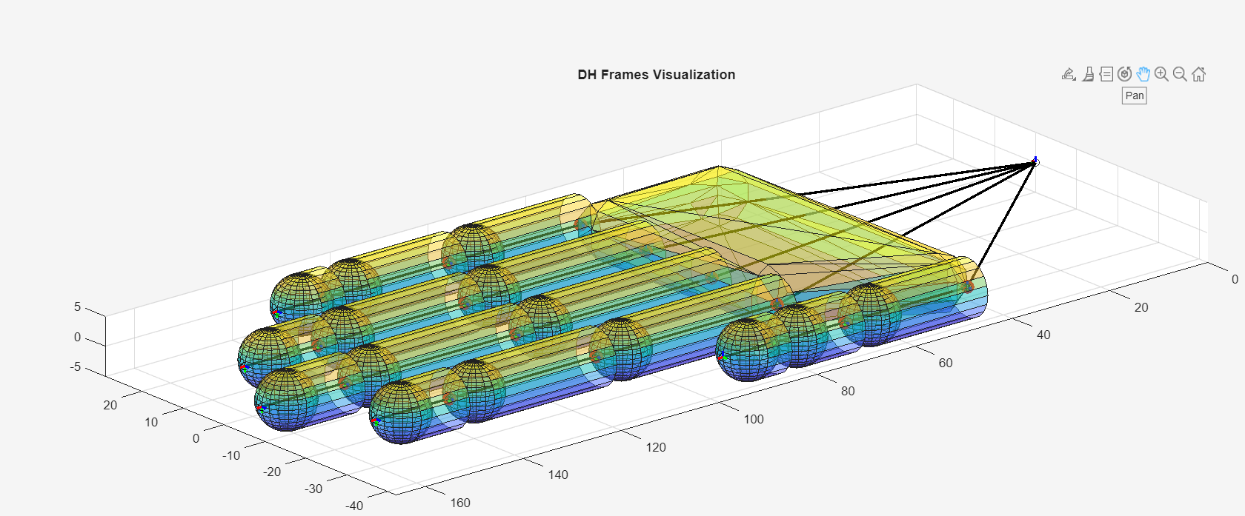
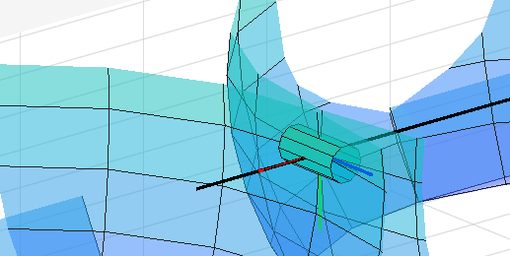
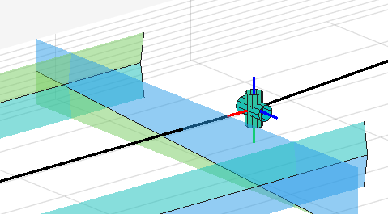
We can analyse the kinematic chains by accessing the hand.F field, which contains the properties for each finger. By inspecting the DHpars matrix within this structure, we verify that the model utilizes Denavit-Hartenberg parameters to define the geometry, with each finger consisting of a four-joint chain: at the base of each finger in fact, two rotational joints overlap to compose a universal joint. To check the frames’ positions, we can generate a 3D visualization using SGplotHand and overlay the local coordinate systems for each link using the function SGhandFrames. The first picture below confirms the placement and orientation of the reference frames relative to the wrist origin, where the black lines point to. The two following figures are zoomed in details.
Figure 3: Paradigmatic Hand
Figure 5: Common Revolute Join in finger
Figure 4: Universal Joint at Index base
Here we can also notice the three axes of each DH frame: the blue one is the Z axis and axis of rotation, the red one is the X axis along the common normal, the green one is the Y axis.
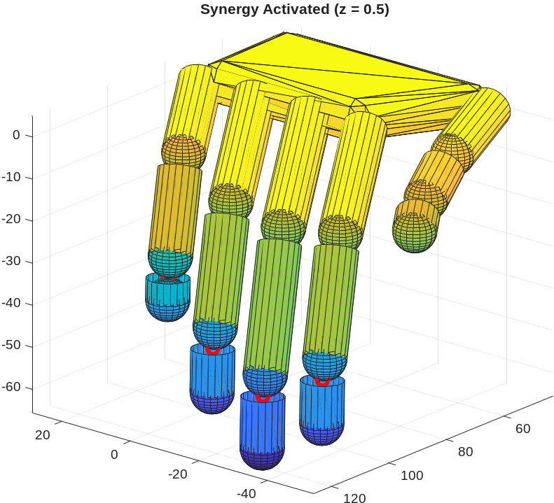
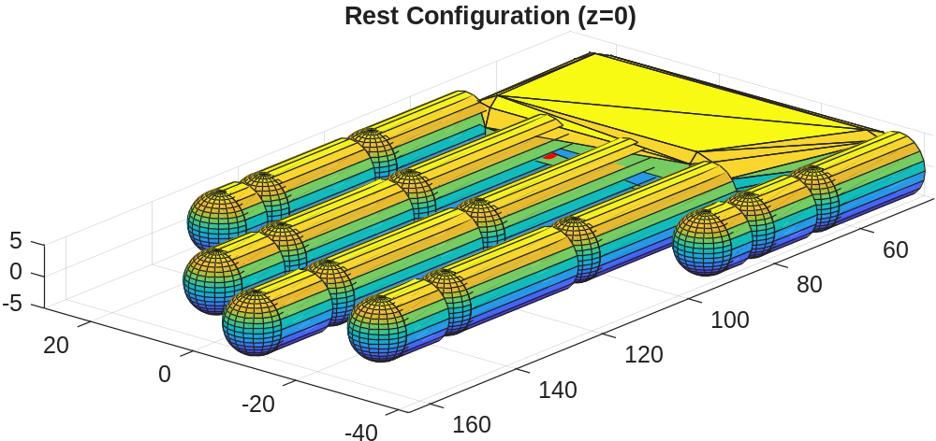
Implementation of Synergy-Based Control
Within the same script, we can also implement a low-dimensional control strategy based on kinematic synergies. The objective is to map a reduced set of control inputs to the high-dimensional joint space (q). The core of this approach is the synergy activation vector, z, which represents the amplitude of activation along specific coordinated motion patterns (synergies). Let’s make this clearer: unlike the joint vector q, which describes the physical angle of every individual motor, z acts as a high-level command. For example, a single value in z can represent the "degree of closure" of the entire hand. We define a custom synergy matrix S (20x1) to link this scalar input to the 20 physical joints. This matrix was associated with the hand model using the function SGdefineSynergies. To simulate motion, we apply a specific input value to z using the function SGactivateSynergies, which computed the final joint displacements via the linear mapping Δq = S*Δz. This demonstrates that modifying the scalar z effectively coordinated the complex actuation of all 20 joints simultaneously.

First steps in GUI mode
The GUI can be opened by running the code in SGSynGrasp_GUI.m
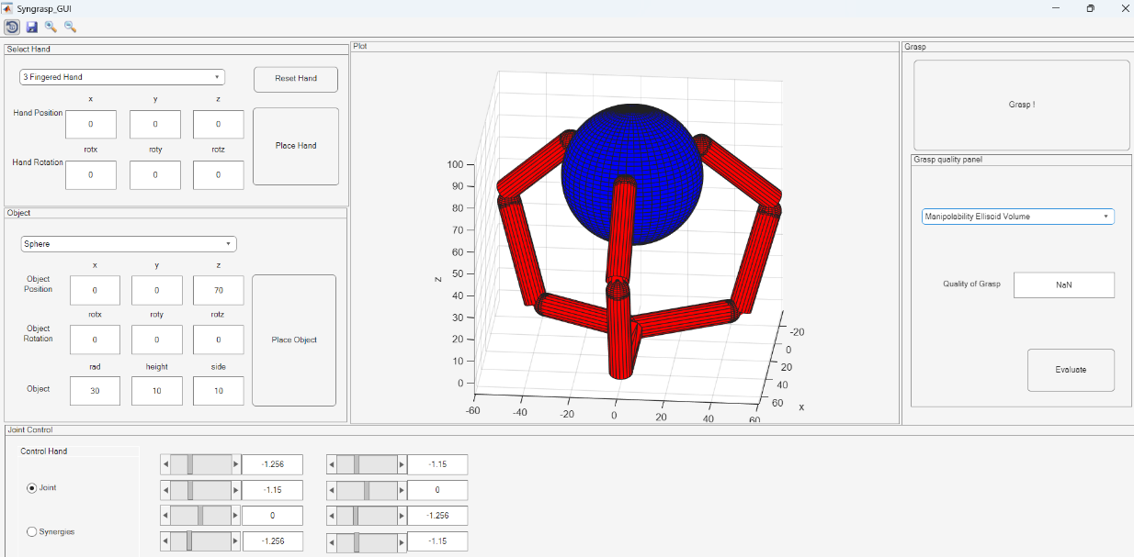
It opens a window, as shown below, that lets you place a hand and an object in a workspace, you can choose among a few options or even load a new hand that must be defined through its Denavit-Hartenberg parameters. Here is an example with a 3 fingered hand, regulated joint-by-joint to hold a sphere.

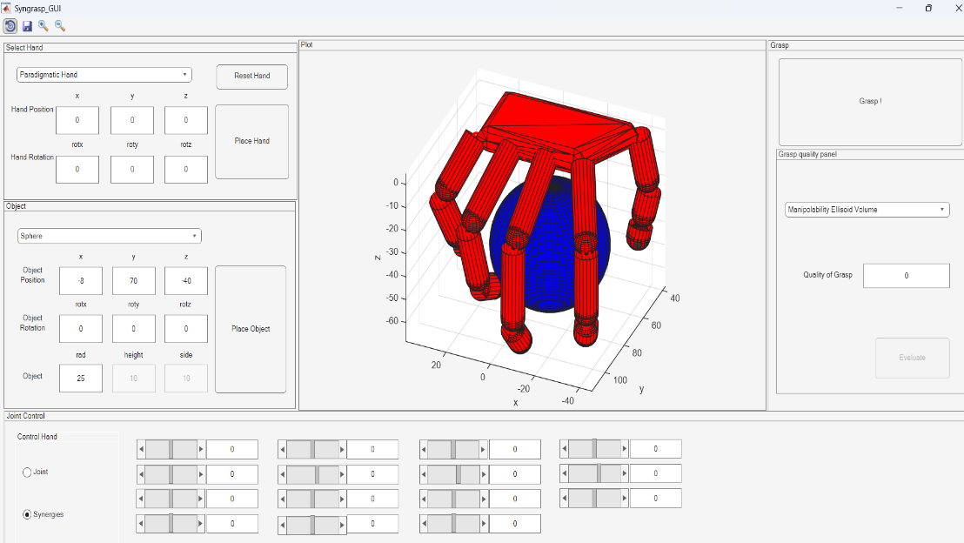
One of the most interesting hands is the paradigmatic hand: a model of the human hand. This hand can be regulated joint by joint through 20 sliders or can be regulated by a smaller set of joints through synergies. One very interesting fact is that, while reference joint configuration (all joint values q set to 0) shows a hand with all fingers straight pointing in the same direction, the reference synergy configuration (all synergy values z set to 0), show the human hand in its natural position, as shown in the figure below.
Clicking the grasp button makes all fingers close onto the object until contact, and it’s also possible to control grasp quality once the object and hand are in contact.

Grasping experiment
Let’s now try a basic grasping exercise in scripting mode (experiment2_AutomaticGraspPlanning.m). We can load the SG3fingered Barrett hand and place it randomly in space near a cube. We then use SGgraspPlanner function. It instructs the hand to close the fingers around the object until contact for a number of attempts, it then returns its best result. We then use SGplotHand and SGplotObject to print the best result obtained.
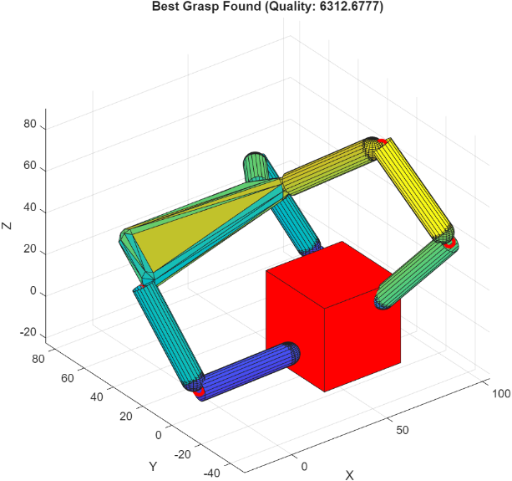
We can then use further functions to compute information about the grasp, such as SGgraspMatrix and SGjacobianMatrix to calculate the necessary inputs to then use SGmanipEllipsoidVolume function, which directly calculates an index of grasp quality. The results of the experiment are depicted in the figure below.
Barrett Hand Grasp

We can notice a visual intersection between the hand links and the object surface. This represents the contact deformation. In the SynGrasp quasi-static model, this penetration depth is utilized alongside the Contact Stiffness Matrix $K_{c}$ to compute the resulting normal and tangential contact forces. We in fact often deal in compliant hands rather than rigid ones, so some overlap is allowed.

Fist Closure Animation Exercise
(experiment4_close_fist.m)
Let’s now try to close a paradigmatic hand into a proper fist using synergies. Our first attempt will use a simple 20x1 synergy matrix and we want to visualise many frames of this movement to properly assess the hand’s motion.
We must customize our S matrix to move only the joints we’re interested in. For example, abduction movements (side-to-side) of the four long fingers must be avoided, we must hence set the movement of the first joint of each of these fingers to zero. We instead set to 1 the value of the other joints.
For the thumb we must work differently. Through some fine tuning and empiric trials we can define the most appropriate parameters, generally lower than the rest in the matrix to avoid collision among fingers.
After defining the reference joint configuration (all q=0) and attaching the synergies through funcion SGdefineSynergies, we’re ready to start simulation. We can break it up into a discrete number of steps where z_current gently transitions from 0 to its final (tunable) end position. This simulation uses z_end = 1.8. We then plot each hand frame taking care of erasing the previous hand position to keep the figure clean.
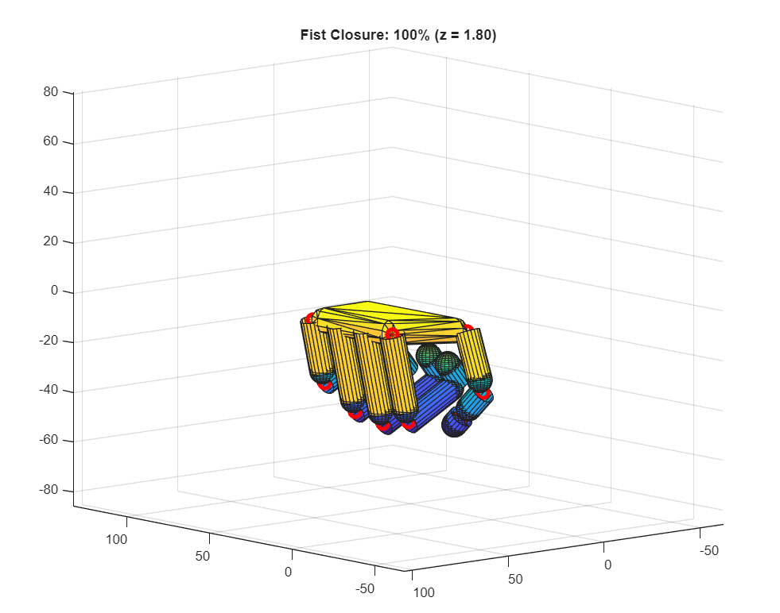
Final position is shown below.
Running the code experiment4_close_fist.m allows you to see the real-time motion of the hand. One of the hardest parts of this code is setting the camera to a sensible position. I chose this configuration because its stable and allows to see the whole hand clearly. Eliminating the hold and view commands allow us a closer but more chaotic point of view.

Santello Matrix Experiment
(experiment5_close_fist_SantelloMatrix.m)
In this experiment, we implemented a control strategy based on the Santello Synergy Matrix, derived from the foundational work of Marco Santello et al. (1998). Unlike the geometric synergies defined in previous experiments, this matrix results from Principal Component Analysis (PCA) applied to experimental data of human grasping. It maps a low-dimensional input vector ($z$) to the 20-DoF joint space ($q$), significantly reducing control complexity while maintaining anthropomorphic motion.
The control inputs ($z$) correspond to the Principal Components (PCs) of the hand's motion variance:
- $z_{1}$ (First Synergy): Represents the dominant motion pattern (approx. 50% of total hand motion), corresponding to the coordinated flexion/extension of all fingers (opening and closing the hand).
- $z_{2}$ and $z_{3}$ (Higher-Order Synergies): Control finer kinematic adjustments, such as finger abduction/adduction (spreading) and thumb opposition, allowing for grasp refinement.
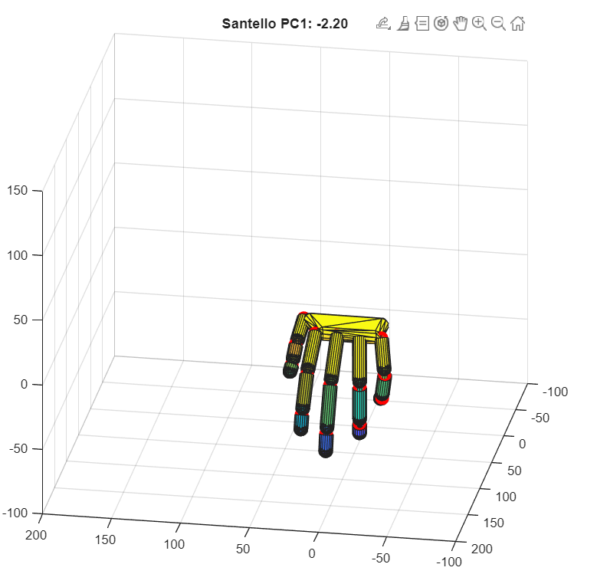
With only three $z$ control inputs, M. Santello’s work shows that up to 90% of common objects can be successfully grasped.
We initialized the SGparadigmatic hand model and applied a rotation to align the base frame with the simulation view. The full synergy matrix was reduced to the first three components ($z_{1},z_{2},z_{3}$), effectively compressing the control space from 20 dimensions to 3. A sign correction was applied to the finger rows of the matrix to align the kinematic direction of the robotic model with the biological data.
The simulation involved linearly interpolating the $z$ vector from a neutral open position ($z≈[-0.1,-0.2,0]$) to a closed grasp configuration ($z≈[-2.2,-0.3,0.5]$), demonstrating that a complex, naturalistic fist closure can be achieved by modulating just three variables. The values we used are not exactly calculated, rather empirically found and can be improved. This experiment simply aimed at showing how some complex hand movements can be regulated by simply tuning 3 control inputs.

Fixed bugs in SynGrasp Library
The library is a very powerful tool, it however has some sporadic minor errors within the official code text and small inconsistencies. I will here list the errors and problems I encountered while working on the toolbox.
- Name inconsistencies
When reading the published papers that describe the names of the functions that are available inside the library, many have been renamed over the course of the years and must hence always be double-checked in the library directory to avoid errors. Since MATLAB is case-sensitive, even a change from a capital to lower-case letter can lead to an error in code execution.
Example: Inside “modeling” folder, the function to define the hand structure, SGmakehand as originally named in [3, Table I], has been renamed in the latest version to SGmakeHand, where the capital H makes a difference for MATLAB compiler.
- Code inconsistencies
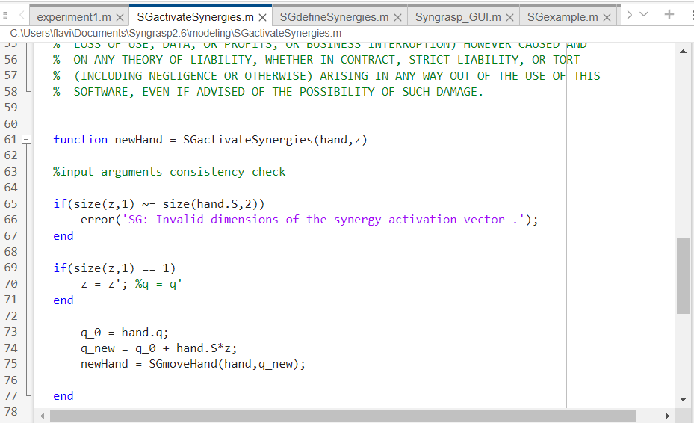
While using SGactivateSynergies function, the MATLAB compiler displayed an error at line 70. Debugging this standard library function was necessary to enable synergy activation, as shown in the code snippet below. The code snippet shows the functioning code and, as a comment, the original code I had to fix, by changing the q into z.
Figure 4: fixed bug at line 70

Esperimento presso Centro Protesi INAIL di Budrio
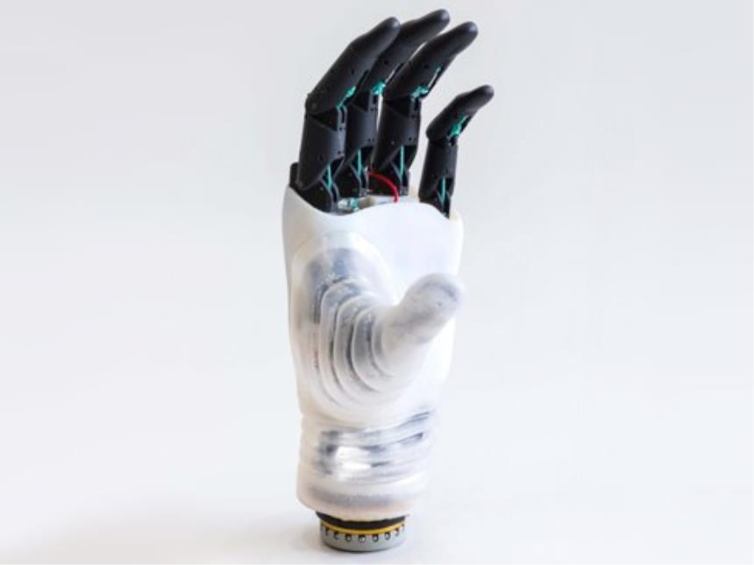
Al fine di acquisire un’esperienza pratica nell’ambito delle mani robotiche, ho collaborato con il professore Roberto Meattini ed il suo team, in particolare Alex Pasquali e Davide Bargellini, per realizzare parte del materiale necessario per un esperimento presso il centro prostetico INAIL di Budrio.
L’esperimento consiste nell’utilizzo della protesi “Mano di Hannes” da parte di un paziente con amputazione transradiale. Il mio contributo personale è stato nella progettazione di un tavolo su cui appoggiare l’oggetto da manipolare (prima un cilindro, poi una sfera, forniti da INAIL) ed un ostacolo da oltrepassare durante la manipolazione dell’oggetto.
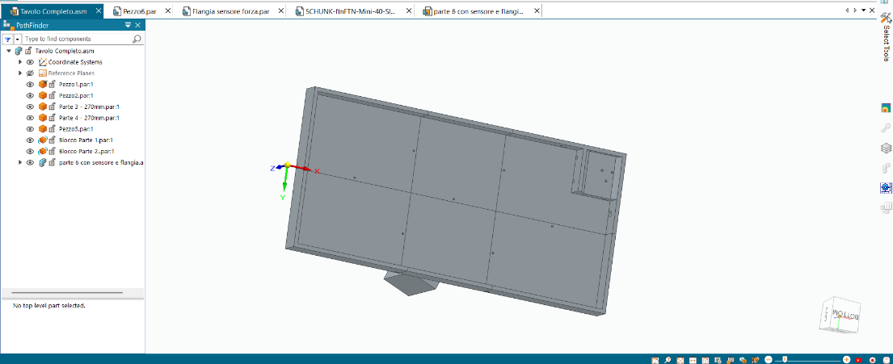
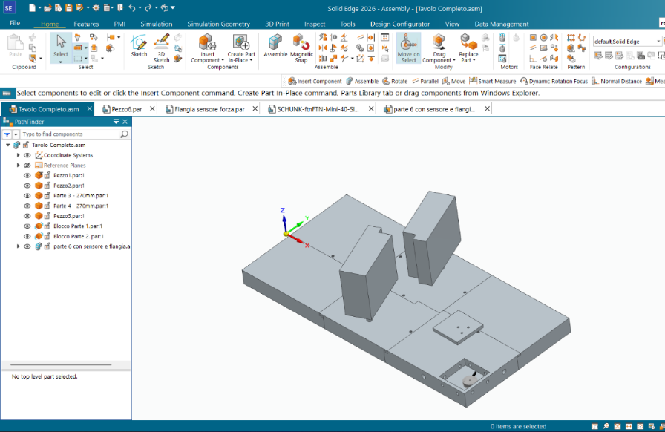
Per progettare il tavolo, che è stato poi stampato in 3D, ho utilizzato il software Solid Edge di Siemens. Il tavolo misura 880x415x10mm ed è stato diviso in 6 moduli da stampare individualmente che devono poi essere assemblati tramite 6 viti. Questa è stata per me un’occasione per approcciarmi al CAD, strumento che non avevo mai utilizzato prima.

Per fare disegno al CAD serve avere astrazione geometrica ed immaginazione, ma soprattutto notevole pazienza e precisione, specialmente per chi è nelle fasi iniziali di apprendimento. Le parti più difficili da disegnare sono stati senza dubbio i fori e le sedi per le viti del sensore di pressione (angolo in basso a destra).

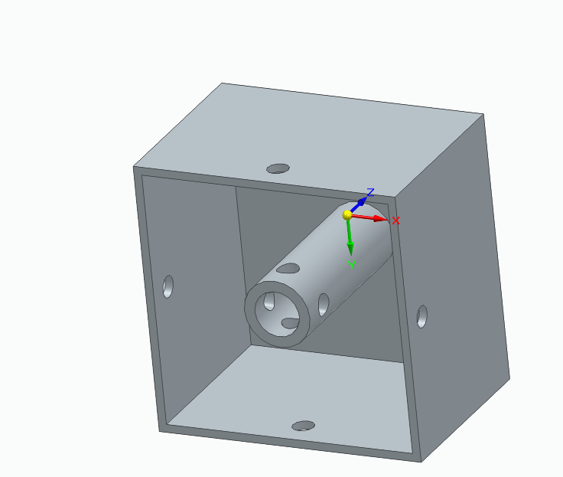
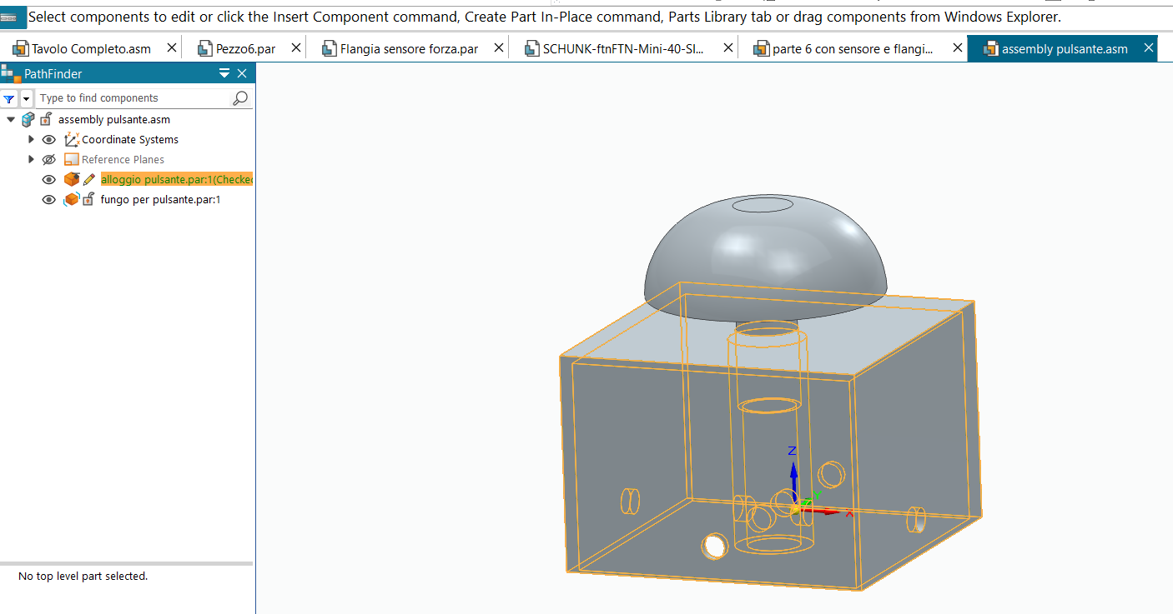
Ho anche disegnato un alloggio per un pulsante. Il pulsante che abbiamo utilizzato è molto piccolo, questa struttura con un fungo è pensata per rendere il pulsante più facile da premere con la mano prostetica.

In entrambi i progetti CAD ci sono molti fori lungo i bordi delle strutture: sono pensati per far passare cavi e fili necessari per i componenti elettronici che sono parte integrante del progetto.

Il giorno dell’esperimento
Venerdì 6 marzo mi sono recato presso il centro INAIL di Budrio. Il paziente protagonista dell’esperimento aveva un'amputazione al braccio destro circa a metà dell'avambraccio, e ha quindi indossato la mano di Hannes dotata di sensori elettromiografici per intercettare dai muscoli rimanenti i segnali per comandare apertura e chiusura della mano robotica.
Mentre il moncone del paziente veniva inserito nell’invaso collegato alla mano di Hannes (procedimento che può durare anche diverse decine di minuti per permettere al paziente di adattarsi lentamente allo strumento) veniva allestito l'esperimento. Esso consiste del tavolo stampato in 3D, di un oggetto appoggiato sopra che il paziente deve manipolare con la protesi, di un muretto che ostacola il movimento, di un pulsante collegato ad una scheda Arduino, di uno schermo davanti al paziente che mostra le istruzioni sui compiti da svolgere e, infine, di tutto il necessario per registrare il processo.
A questo punto l'esperimento si articolava in quattro fasi.
Il paziente si siede al tavolo davanti al setup. Sullo schermo compare un video che mostra l'oggetto partire dall'estremità sinistra del tavolo e muoversi verso quella destra. Quando l'oggetto tocca la destinazione (misurata da un sensore di forza) viene riprodotto un suono dal computer con un certo ritardo rispetto a quando viene appoggiato l'oggetto. Il ritardo è variabile tra 1ms e 800ms. Il paziente vede a quanto ammonta il ritardo ogni volta e si allena a fare personalmente stime accurate.
Nella seconda parte il paziente manipola personalmente l'oggetto e di nuovo viene informato del ritardo dopo ogni iterazione per continuare l’addestramento.
Nella terza parte l'oggetto resta fermo e riparte il video, ma viene chiesto al paziente di provare a stimare il ritardo e di rispondere inoltre ad alcune domande su come percepisce la protesi che indossa.
Nella quarta parte il paziente deve sia spostare personalmente l'oggetto che stimare autonomamente il ritardo del suono emesso e rispondere alle stesse domande su come percepisce la protesi indossata.
Il procedimento è stato ripetuto per un cilindro leggero, uno pesante e per una sfera leggera. Ogni volta che cambiava l’oggetto, al paziente è stato sottoposto un ulteriore questionario per valutare le prestazioni della mano robotica indossata.
Dopo tutti questi esperimenti, il paziente ha anche affrontato un’altra breve prova di manipolazione: un test chiamato SHAP (Southhampton Hand Assessment Procedure). È un test che misura la velocità con cui il paziente riesce a spostare determinati oggetti di peso variabile da un punto ad un altro di un’apposita tavola.
L’obiettivo dell’esperimento mirava a dimostrare come, man mano che il paziente si abitua ad utilizzare la protesi e sente lo strumento come proprio, cambi la percezione del ritardo del suono emesso dal computer. Tutti i dati raccolti saranno oggetto di ulteriore studio e analisi e andranno confrontati con quelli di una persona non amputata che indossa la mano di Hannes sotto la propria mano vera e ripete lo stesso esperimento.

Riflessioni personali e conclusione
L’esperienza di tirocinio è stata per me formativa e stimolante e mi ha permesso di approfondire temi altrimenti difficili da affrontare durante il classico percorso accademico. È stato affascinante interfacciarmi con la libreria SynGrasp per simulare i movimenti di apparati robotici che avevo finora solamente studiato e disegnato in maniera teorica nei corsi universitari seguiti.
La possibilità di partecipare all’esperimento presso INAIL mi ha permesso di apprendere l’utilizzo del CAD di Siemens, strumento che ritengo necessario conoscere per la mia carriera di futuro ingegnere e di esplorare il mondo delle protesi robotiche.
L’esperimento presso INAIL è stato senza dubbio la parte che mi ha sorpreso di più. Sono rimasto meravigliato dall’abilità con cui il paziente riuscisse a manipolare oggetti tramite la mano di Hannes e di come abbia affermato di sentire la protesi come propria e di averne il pieno controllo.
Tuttavia, ha anche asserito che lo strumento è ancora molto lontano da una fedele ricostruzione di una mano vera, perché sebbene sia nella posizione in cui dovrebbe essere, ha ancora molti comportamenti e caratteristiche che la rendono innaturale.
Questa esperienza mi ha dunque arricchito ed appassionato ad un tema che prima conoscevo solo marginalmente e di cui ora apprezzo le complessità e le sfide ancora irrisolte.
Mi ritengo attualmente molto motivato a continuare i miei studi nel settore, su cui intendo incentrare la mia tesi triennale.

References
[1] Foundation of Industrial Robotics Bachelor course by C. Melchiorri and R. Meattini at University of Bologna.
[2] YouTube Video Course by D. Prattichizzo, professor of SIRSLabRobotics of University of Siena
[3] M. Malvezzi, G. Gioioso, G. Salvietti, D. Prattichizzo, and A. Bicchi, "SynGrasp: A MATLAB Toolbox for Grasp Analysis of Human and Robotic Hands," in Proceedings of the 2013 IEEE International Conference on Robotics and Automation (ICRA), Karlsruhe, Germany, 2013, pp. 1088-1093.
[4] M. Malvezzi, G. Gioioso, G. Salvietti, and D. Prattichizzo, "SynGrasp: A MATLAB Toolbox for Underactuated and Compliant Hands," IEEE Robotics & Automation Magazine, vol. 22, no. 4, pp. 52-68, Dec. 2015.

Flavio Davide Borriello
0001116354
Ingegneria dell’Automazione – Università di Bologna
Professore di riferimento: Roberto Meattini

